ASSEMBLY TIME

One of the most underrated factors. A common optimum assembly time for products is 105% - 120%, but the real optimum assembly time can greatly go beyond this range, as it depends on:

1. Elasticity factor.
2. Features of the factor influence on demand.
3. Pay rate.

**Elasticity factor**

In the graph test results of assembly time for product 1 among 5 teams in the same group (and it is not to much for such coincidences to happen) in previous version GMC simulator. Factor mechanics in new version GMC simulator has not changed, so information is still relevant. Vertical - relative change in demand compared with previous period. Horizontal - relative value of assembly time in % from normal time. EU - blue, Nafta - red, Internet - green.

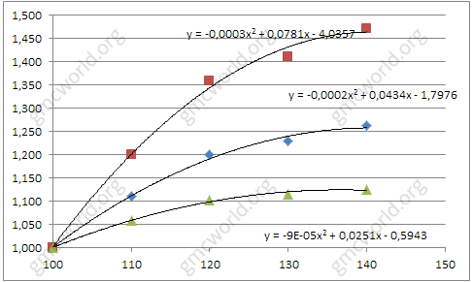

The relationship between the assembly and the demand is a quadratic function that will be unique to each market and product.

**Features of the factor influence on demand**

Increasing assembly time will be reflected in increasing sales over 1 period, but decreasing assembly time will decrease sales in current period. It is important to remember and to calculate optimal value before the game for all 5 periods, to prevent extra costs. For example, in scenario 12C3 in 1 period is shortage of workers to implement production plan. So you can not increase assembly time to optimum value 120%. At the same time labor market has shortage of qualified workers and in 2 period you also probably will not be able to hire required number of workers. As a result, in 2 period, you also can not increase assembly time to the optimum. At last by 3 period required number of workers are hired, but remember that effect on demand will act only through 1 period, it means in 4 and 5 periods only, and 3 period you will work "for free". In this situation, raising assembly time to 120% is no sense, it is not profitable, so you should leave it as is.

**Pay rate**

Main thing you should pay attention. Between pay rates 10.00 and 13.50 is a huge difference. At rate 10.00 you can safely increase assembly time up to 125% - 130%, low salary costs offset costs of high assembly time. While at pay rate 13.50 setting assembly time above 120% is dangerous, because salary costs will “eat” effect of sales growth.

**Hints**

1. No residual effect.
2. Effect is different between markets and products.
3. Competitors in the group affect on sales.

组装时间

其中一个被低估的因素。 产品常见的最佳组装时间为105％ - 120％，但实际最佳装配时间可大大超出此范围，因为它取决于：

1．弹性系数. 。

2．影响需求因素的特征。

3．工资率。

**弹性系数**

在以前版本的GMC模拟器中，在同一组中的5个队中的产品1的装配时间的图形测试结果（并不是太多的这种巧合）。 新版GMC模拟器中的因子力学没有改变，所以信息仍然是相关的。 垂直－需求相对于上期的相对变化。水平－装配时间的相对值，以正常时间为单位。国内－蓝色，北美－红色，互联网－绿色。



装配与需求之间的关系是对每个市场和产品都是独一无二的二次函数。

**影响需求因素的特征**

增加装配时间将反映销售额的增长在下一期，但是降低组装时间就会马上降低目前的销售额。 在所有5个周期之前，记住并计算游戏之前的最优值是很重要的，以防止额外的成本。例如，在12C3第1期的情景中，缺乏工人执行生产计划。 因此，您不能将装配时间增加到最佳值120%。 同时劳动力市场缺乏合格的工人，在第2期，你也可能无法雇佣所需的工人人数。 因此，在第2期，您也不能将装配时间增加到最佳状态。 最后第3期需要雇用的工人人数，但请记住，只有通过1个时期的需求影响，仅在4个和5个时期，3个工作日将“免费”工作。 在这种情况下，将组装时间提高到120％是没有意义的，它不是有利可图的，所以你应该维持。

**工资率**

主要事情你应该注意。薪酬10.00和13.50之间是巨大的差异。在10.00的工资率，您可以安全地将组装时间增加到125%－130%，低工资成本抵消了高装配时间的成本。而在工资率13.50的时候，组装时间在120%以上是很危险的，因为工资成本会“吃掉”销售增长的影响。

**提示**

1．没有残留效应。

2．对各市场和产品的影响是不同的。

3．小组中的竞争对手会对销售产生影响。